**N-CW7**

**Product Requirements Specification**

**250204-800**

1. Document Information 3

1.1 Current Release Document Control & Authorisation 3

1.2 Change History 3

2. References 4

3. Definitions 4

4. Purpose 5

5. Requirements 6

# Document Information

## 

## 1.1 Current Release Document Control & Authorisation

|  |  |  |  |
| --- | --- | --- | --- |
|  | Name | Signature | Date |
| Prepared by: | Emilio La Greca | Emilio | 04/02/25 |
| Modified by: |  |  |  |
| Checked by: | Emilio La Greca | Emilio | 04/02/25 |
| Approved by: | Ramin Mousavi | Ramin | 04/02/25 |

## 1.2 Change History

|  |  |  |  |  |
| --- | --- | --- | --- | --- |
| **Issue** | **Date** | **Change Details** | **Change by** | **Approved by** |
| 1.0 | 04/02/25 | First release. | Emilio | Ramin |
|  |  |  |  |  |
|  |  |  |  |  |
|  |  |  |  |  |
|  |  |  |  |  |
|  |  |  |  |  |
|  |  |  |  |  |

# References

The following documents and standards listed in Table 2a have been used as references in the preparation of this Product Requirements Specification.

|  |  |  |
| --- | --- | --- |
| **Document Name** | **Document No.** | **Issue Number Used** |
|  |  |  |
|  |  |  |
|  |  |  |

**TABLE 2a: Documents referred to within this document**

# 3. Definitions

|  |  |
| --- | --- |
| **Abbreviation** | **Description** |
| USB | Universal Serial Bus |
| API | Application Programmers Interface |
| SWD | Serial Wire Debug |
| UART | Universal Asynchronous Receiver-Transmitter |
| I2C | Inter-Integrated Circuit |
| RS232 | Recommended Standard 232 |
| RS485 | Recommended Standard 485 |
| TI | Texas Instruments |
|  |  |
|  |  |
|  |  |
|  |  |
|  |  |
|  |  |

# Purpose

The purpose of this document is to broadly detail the requirements of the N-CW7 Networker Controller that includes embedded Wi-Fi as an option.

# Requirements

The existing Rinnai N-C7 Touchscreen controller platform is to be upgraded to include embedded Wi-Fi as an option. This is a 3-tier project that encompasses the following distinct areas:

* Hardware modification of existing hardware platform.
* Firmware modification of existing firmware.
* Software modification of test / debug Windows based software.

The scope of this requirement specification is the **hardware modification** of the existing hardware platform illustrated below:

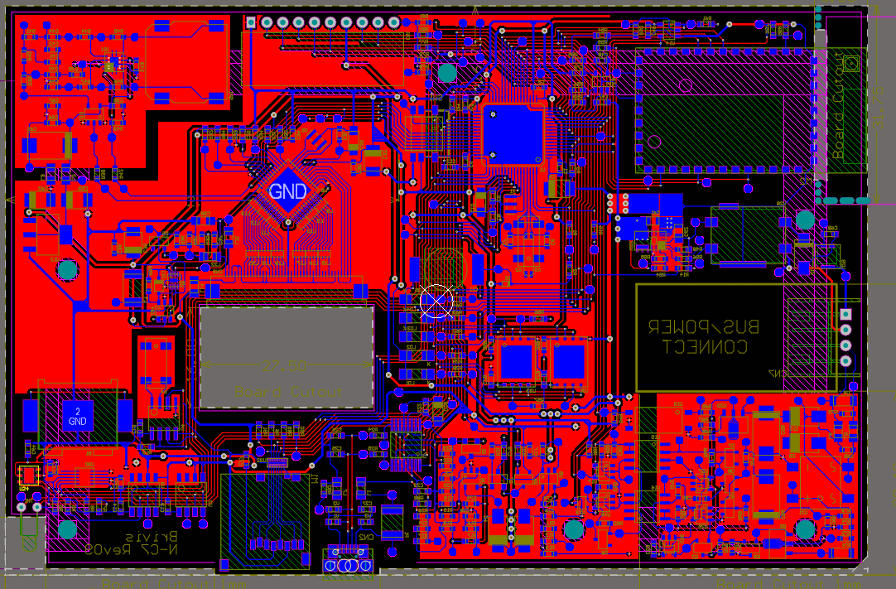

**Area provided to allow for Wi-Fi Module**

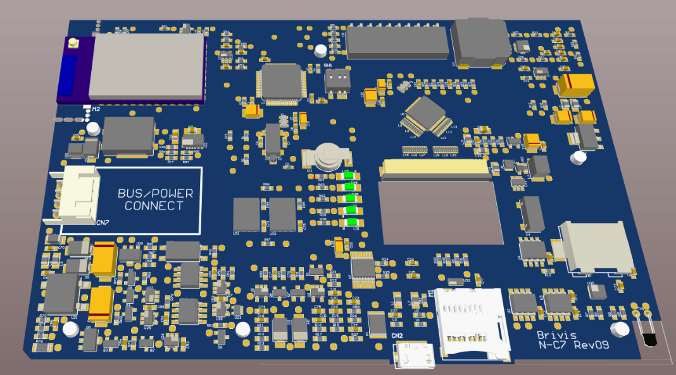

**Existing N-C7 Hardware Platform**

Requirements summary:

* The hardware upgrade is to allow for a Wi-Fi module to be integrated based on the TI CC3200 family, starting with the current in-use CC3200MODR1M2AMOBT device which is used in the Rinnai N-BW2 Touch Wi-Fi Module:

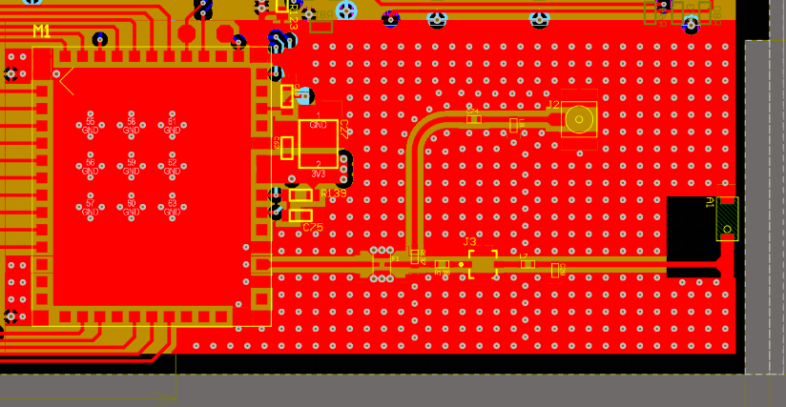

**Existing N-BW2 Wi-Fi Module**

* The CC3200 module is to be provided on a solderable PCB interfaced via castellated pads so this module can be easily replaced with minor modification to the N-CW7 baseboard allowing for future Wi-Fi based modules (future proofing).
* USB access to the CC3200 module is to be provided to program and monitor its operation with direct connection access to the STM32 microcontroller currently used in the touchscreen controller.
* Remove unused hardware peripherals on the touchscreen controller:
* Audio output.
* SD card reader.
* External RTC.
* Upgrade all components to Innotechs standard 3D-Bodies.
* Strictly follow the Wi-Fi module track routing and placement guidelines stipulated by TI.

Schematic / PCB files in Altium format will be provided for both products.